# Data and Artificial Intelligence

# Cyber Shujaa Program

# Week 4 Assignment Portfolio Website

**Student Name:** Jasper Wambugu

**Student ID:** CS-DA01-25045

## Introduction

This week’s assignment was mainly aimed at us creating a professional [portfolio website](https://jasper-wambugu-dev.netlify.app/) that captures our CV/resume, showcases our projects, and presents writeups to lab-based challenges.

The portfolio includes the following:

1. **Home page** that captures your photo, name and professional statement/tagline
2. **Resume outline**that captures your academic background, work experience, certifications, and skills
3. **Projects section** that showcases at least 3 projects. These could be from the ongoing training or your university academic work,
4. **Lab Challenges section** that showcases some lab challenges you have completed. These could be from ongoing training or your personal interest in CTFs. Include the problem statement, approach, tools used, screenshots (if applicable), and key lessons learned
5. **Contacts section** with professional links (LinkedIn, GitHub, Email) or telephone, so that people can reach you with

## Assignment Link

[PORTFOLIO LINK](https://jasper-wambugu-dev.netlify.app/)

## Tasks Completed

1. Home Page

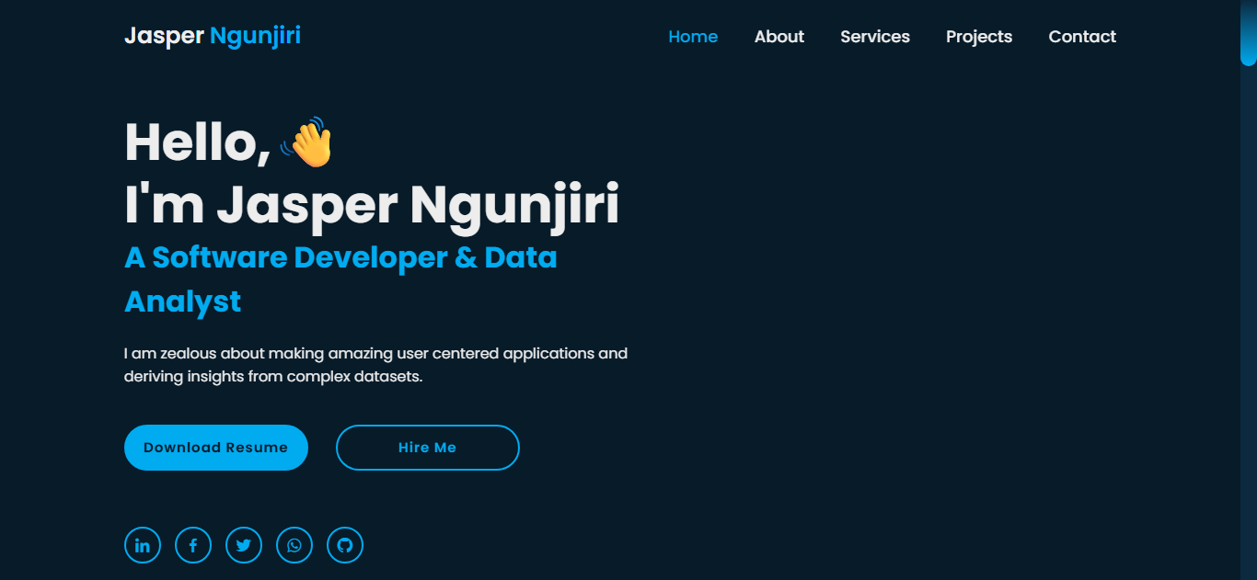

1. Resume Outline

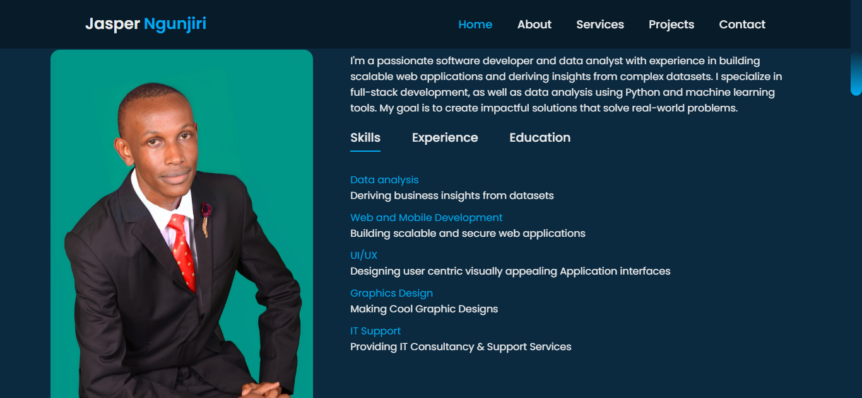

1. Lab Challenges Section

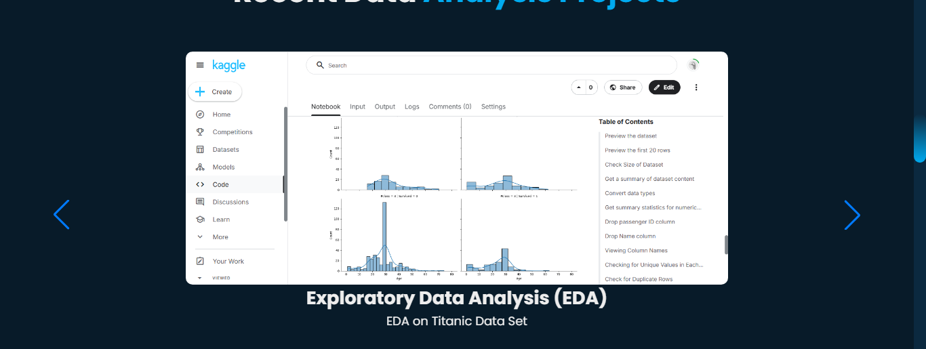

1. Projects Section

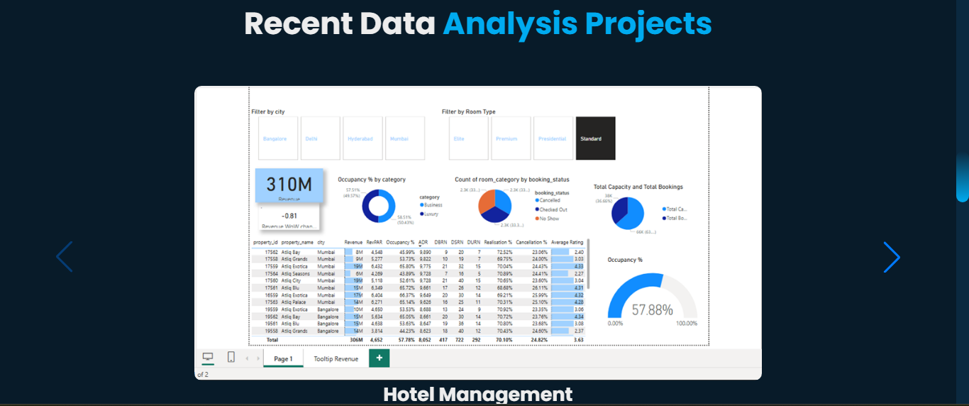

1. Contact Section

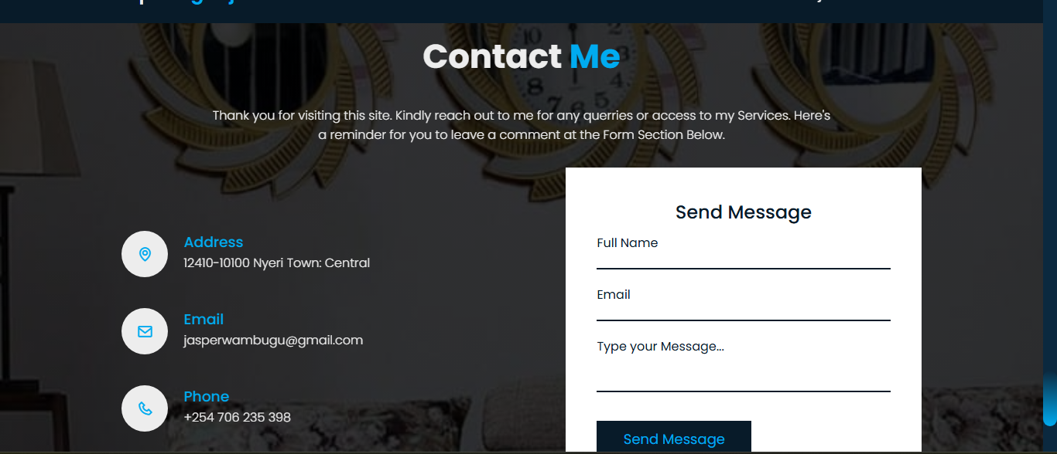

## Conclusion

Working on my portfolio has been really captivating and I am excited to improve it further and showcase it with friends and potential employers. Looking forward to future sessions and classes.